**Rewriting the recommendations for Computational Thinking, based on elaborations APEC Meeting on Computational Thinking Curriculum for the Digital Economy: Synthesis Meeting for Recommendation.**

**November 18-20, 2019,**

**Thailand**

**Computational thinking (CT)**

CT is a problem-solving process that includes the following characteristics:

* Formulating problems in a way that enables us to use a computer and other tools to help solve them
* Logically organizing and analyzing data
* Representing data through abstractions such as models and simulations
* Automating solutions through algorithmic thinking (a series of ordered steps)
* Identifying, analyzing, and implementing possible solutions with the goal of achieving the most efficient and effective combination of steps and resources
* Generalizing and transferring this problem-solving process to a wide variety of problems

Four basic elements of Computational Thinking Skills are

* Decomposition,
* Pattern Recognition,
* Algorithm and
* Abstraction.

**Three pillars of Computational Thinking**

* Programming and algorithmic thinking (for example text analysis)
* Computer modeling (for example in chemotaxis, cliodynamics)
* Machine Learning (for example medical and machine diagnosis)

**Decision tree to choose computational thinking strategy**

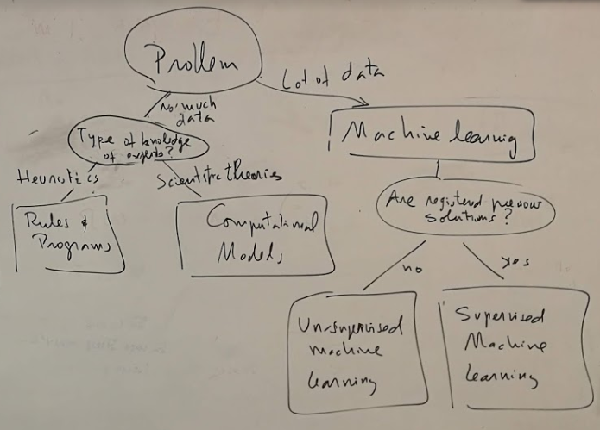

This means that when solving a problem we have to consider and assess first the amount of data available. If there is not much data then we have to consider the type of knowledge required to solve it. If it is mainly heuristics, then we have to specify the rules and build the code. For example, building expert systems with hundreds of rules. However if there are mathematical model that can be translated onto computer models then this type of models should be included. For example, models that represent dynamics with discrete time and discrete space. On the other hand, if there is huge amount if data, then a machine learning model can be built. In this case the system is not programmed but trained with the data.

**Definitions:**

Algorithmic Thinking

<https://sites.google.com/site/digitalculturewiki/terms/terms-a/algorithmic-thinking>

Algorithmic thinking occurs when someone observes repeated patterns in problems and then generalizes a set of rules for dealing with such situations (so that one need not think this through anew each time that problem occurs). In effect, one creates (formally or informally) an algorithm or rational procedure. This is a kind of strategizing that embeds intelligence into routine and thereby conserves cognitive resources. This sort of thinking is often used in games, as well as in computer programming, and can be considered as a subset of computational thinking in general.

Computational models

<https://en.wikipedia.org/wiki/Computational_model>

A computational model is a mathematical model in computational science that requires extensive computational resources to study the behavior of a complex system by computer simulation.

Artificial intelligence

<https://en.wikipedia.org/wiki/Artificial_intelligence>

In computer science, **artificial intelligence** (AI), sometimes called machine intelligence, is intelligence demonstrated by machines, in contrast to the natural intelligence displayed by humans. Leading AI textbooks define the field as the study of "**intelligent agents**": any device that perceives its environment and takes actions that maximize its chance of successfully achieving its goals.

Machine learning

<https://en.wikipedia.org/wiki/Machine_learning>

**Machine learning** (ML) is the scientific study of algorithms and statistical models that computer systems use to perform a specific task **without using explicit instructions**, relying on patterns and inference instead. It is seen as a subset of artificial intelligence. Machine learning algorithms build a mathematical model based on sample data, known as "**training data**", in order to make predictions or decisions without being explicitly programmed to perform the task.

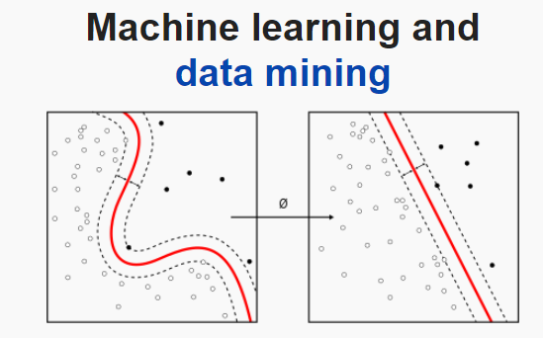

Scatter plots illustrating the core idea of finding a curve that discriminate two regions

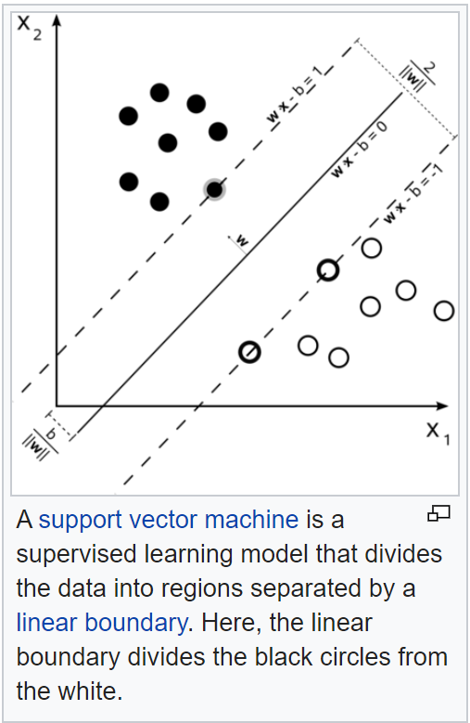

A linear discriminator using Support Vector Machine (SVM) method that finds a linear curve (model).

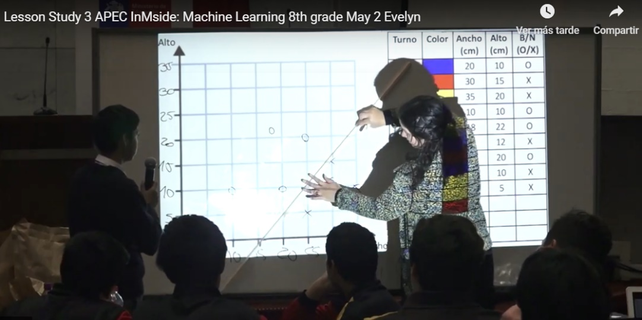

Scatter plot and a linear discriminator (SVM) at the exemplar shown in the Open Lesson at the Chilean National Congress, May 2, with an 8th grade class

Data Science

Data science is the field of study that combines domain expertise, programming skills, and knowledge of math and statistics to extract meaningful insights from data. Data science practitioners apply machine learning algorithms to numbers, text, images, video, audio, and more to produce artificial intelligence (AI) systems that perform tasks which ordinarily require human intelligence.

**Why machine learning is so popular currently?**

<https://www.educba.com/what-is-machine-learning/>

* The increasing availability of data
* Huge increase of computer power
* Increasingly effective machine learning algorithm

**Humanistic nature and Philosophy of AI**

<https://en.wikipedia.org/wiki/Philosophy_of_artificial_intelligence>

Artificial intelligence has close connections with philosophy because both share several concepts and these include **intelligence, action, consciousness, epistemology,** and even **free will**. Furthermore, the technology is concerned with the creation of artificial animals or artificial people (or, at least, artificial creatures) so the discipline is of considerable interest to philosophers. These factors contributed to the emergence of the philosophy of artificial intelligence.

**Machine learning models**

**Artificial neural networks**

Artificial neural networks (ANNs), or connectionist systems, are computing systems vaguely inspired by the biological neural networks that constitute animal brains. Such systems "learn" to perform tasks by considering examples, generally without being programmed with any task-specific rules.

**Decision trees**

Decision tree learning uses a decision tree as a predictive model to go from observations about an item (represented in the branches) to conclusions about the item's target value (represented in the leaves).

**Support vector machines (SVM)**

An SVM training algorithm is a non-[probabilistic](https://en.wikipedia.org/wiki/Probabilistic_classification), [binary](https://en.wikipedia.org/wiki/Binary_classifier), [linear classifier](https://en.wikipedia.org/wiki/Linear_classifier).

**Bayesian networks**

A Bayesian network, belief network or directed acyclic graphical model is a probabilistic [graphical model](https://en.wikipedia.org/wiki/Graphical_model) that represents a set of [random variables](https://en.wikipedia.org/wiki/Random_variables) and their [conditional independence](https://en.wikipedia.org/wiki/Conditional_independence) with a [directed acyclic graph](https://en.wikipedia.org/wiki/Directed_acyclic_graph) (DAG)

**Genetic algorithms**

A genetic algorithm (GA) is a [search algorithm](https://en.wikipedia.org/wiki/Search_algorithm) and [heuristic](https://en.wikipedia.org/wiki/Heuristic_(computer_science)) technique that mimics the process of [natural selection](https://en.wikipedia.org/wiki/Natural_selection), using methods such as [mutation](https://en.wikipedia.org/wiki/Mutation_(genetic_algorithm)) and [crossover](https://en.wikipedia.org/wiki/Crossover_(genetic_algorithm)) to generate new [genotypes](https://en.wikipedia.org/wiki/Chromosome_(genetic_algorithm)) in the hope of finding good solutions to a given problem.

**Machine learning models feasible to teach at Middle and high school**

Decision trees and SVM core ideas can be implemented in middle and high school using

* 2 dimensional scatter plots and
* Drawing discriminators with a rule.

**Curriculum reform framework**

In order to materialize the new curriculum underlying the above said entities, a Curriculum Reform Framework model has to be established for the curriculum development process. This model will become the reference implementation framework model in carrying out the design process of curriculum formulation and implementation of the new curriculum proposed in each APEC member economies for high school, middle school and primary school respectively.

The propose curriculum reform framework is based on the following implementation framework model.

The framework is divided into two main layers which are the conceptual framework and development framework.

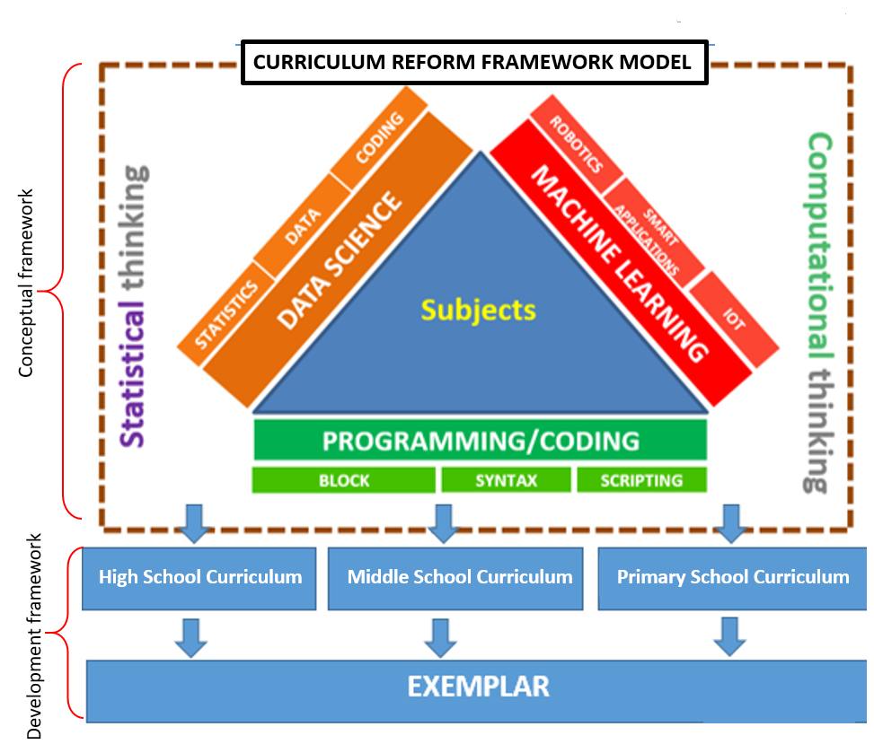

I agree with *Programming/Coding* and *Machine Learning*, but *Data Science* belongs to Statistical Thinking. Some of its components also are part of Machine Learning. I find that is missing *Computational Models.* Thus I suggest to change Data Science to Computational Models as in the next figure:

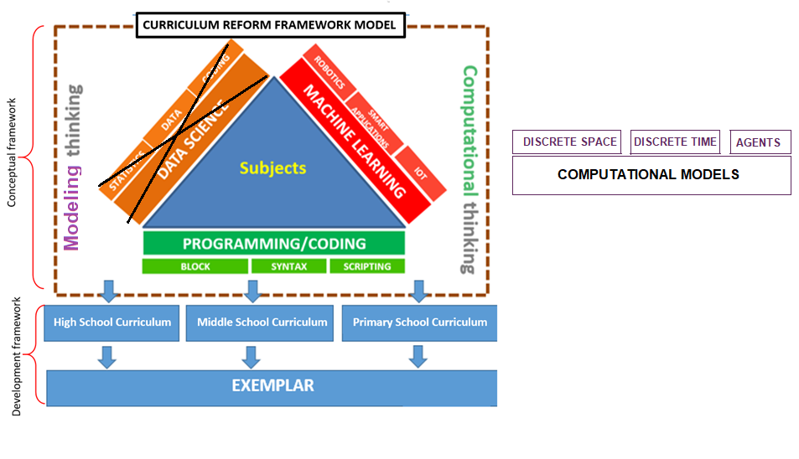

The conceptual framework

It defines the important aspects to be addressed in the new curriculum based on the key elements underlined whether it becomes a subject-based curriculum, thematic, interdisciplinary or embedded across curricula. While it is also important for economies to decide on whether to adopt Standard-based Curriculum or Outcome-based Curriculum or Competency-based Curriculum.

The development framework

Where curriculum developers refer the implementation framework model and take the necessary actions in designing and developing the new curriculum at high school, middle school and primary school based on the following fundamental curriculum components:

Content

Refers to the syllabus developed on the content of the knowledge discipline and also the scope of the content based on the learner’s cognitive level. The respective knowledge, skills and values are determined accordingly.

Pedagogy

Refers to how knowledge or content is imparted or transferred to the learner. This is done through various T&L strategies for teachers to adopt in order to achieve the objective of the lesson.

Assessment

Refers to the ways in determining the performance of the learner in learning by using various assessment tools

Teaching and Learning Resources

Materials including hardware and software that are used to assist learners to meet the expectations for learning based on the specified curriculum. Exemplars will be the main reference for teachers in realizing the new curriculum through documented teaching and learning activities which covers all the curriculum components.

Time Allocation

Specified period of time (minimum hours per year) for teaching and learning to take place within school time table according to the scope of content determined in the syllabus at every level of schooling.

**Exemplars**

Exemplars are examples of best practice in which are designed to assist learners to increase their understanding of particular skills, content or knowledge in any given situation and articulate established criteria and standards in the new curriculum. By using exemplars, it is a way to clearly explain and realize the curriculum into teaching and learning practice that can easily understood and carry out by teachers. Exemplars are often used particularly during training or orientation courses in disseminating the curriculum.

**Exemplar 1:**

 

In mining, large trucks are critical. Therefore, a sample of engine oil is taken from every truck every 3 days and an analysis is performed. One of the problems is to detect as early as possible water contamination. If so, the truck should be immediately sent for maintenance.

The following table lists samples from 16 cases from trucks from the Chuquicamata copper mine (Reynolds, A. & Araya, R. (1995) *Building Multimedia Performance Support Systems*. McGraw-Hill, New York.). In 9 cases, after opening the engine, maintenance personnel found that the engine was in a normal condition. In 7 cases they found that the engine had water contamination. In the lab analysis of the engine oil, the lab technicians measured the particles per million of Fe, Cu, Na and they also measured the flash point of the oil.

The challenge is to develop a program or bot that reads the oil data and without stopping the truck and opening the engine, and automatically predicts whether the engine is normal or with water contamination.



There are 6 scatter plots

If we select the third scatter plot then with a ruler any student can draw a line separating black versus white dots, as shown in the next figure:

This, this red line drawing can be translated in a decision tree, which has been learned by this simple Machine Learning Algorithm.

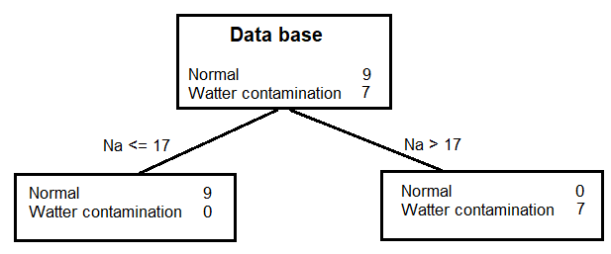

This means that the data base has 16 cases, where 9 of them were normal and 7 of them had Water contamination. However on those cases with Sodium (Na) concentration less than or equal to 17 particles per million (ppm) all the 9 cases were normal. And, those cases with Na concentration higher than 17 ppm all of them had water contamination.

**Exemplar 2:**



Understanding of the outbreak of 2019 novel coronavirus (2019-nCoV).

The first 17 deaths are in the following table (simplified version of Wang, Tang Wei, 2020, Updated understanding of the outbreak of 2019 novel coronavirus (2019-nCoV) in Wuhan, China. Journal of Virology. 29 January 2020 <https://doi.org/10.1002/jmv.25689>

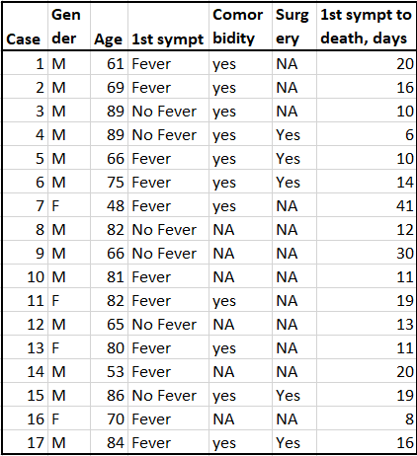





Up to February 9th, there have been:

* 814 deaths
* 37,595 cases
* 6,196 cases in severe conditions

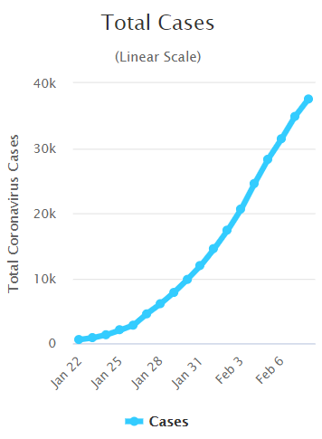 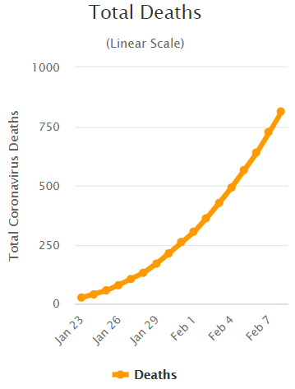

If the information of these cases is obtained in detail as in the previous table with the first 17 cases, then two **Machine Learning** strategies can be done.

* **Death** versus **No Death**
* **Severe Condition** versus **Non Severe Condition**

With the first data base Machine learning can be applied to detect features or combination of features that will predict deaths. With the second data base Machine Learning can help find features or combination of features that will predict severe condition.

**Important Points to Consider**

**Veracity of data**

There is a need to point out that big data has its own implication especially on the aspect of the veracity of data in the modern age of IR4.0. The question of accuracy, trustworthy and precision are always a major concern when dealing with large data sets. Large amount of time is used to clean the data whether it involves structured or unstructured data. Therefore it is imperative to address this issue to the learners that they have to be very mindful on the implications and effects in making decisions based on analyzed data. Proper procedure has to be formulated in carrying out big data processing and analysis in order to achieve prudency in the findings and eliminate negative ripple effects in decision making that could create destructions.

**Humanity & Values**

Hence, the value of humanity, ethics, integrity, truthfulness, honesty and responsibility are the essence of important traits to educate learners towards future well-being and balance to the disruptive nature created by AI and Big Data in Industrial Revolution 4.0.

**Suitability of Students Cognitive Level**

It is important to develop sound curriculum content and learning resources that are suitable for the learners’ cognitive levels and abilities with different learning behavior. The scope of learning at each level of schooling has to be structured in order to achieve meaningful learning experience to the learner.